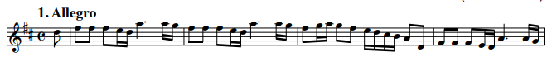
Question 0 (0/1)
Looking at the visual information on the image, can you find any kind of music representation in it? Answer only with “Yes”, if there is any kind of music representation on the image, or “No”, if there is not.
1 | “Yes” (for all scores)
0 | “No”
Question 1 (0/1)
What type of musical notation is used in this excerpt? Choose between: modern notation, tablature, mensural notation, Korean notation, “other notation” or “no music notation present”. Answer only with the name of the musical notation used in the excerpt.
1 | “Modern notation”, “Common western notation”... (for all scores)
0 | Any other answer
Question 2 (0/1)
Based solely on the music sheet image provided, can you determine which musical work this excerpt belongs to? Please use the melody’s rhythmic patterns, note sequences, and any other musical clues to make your deduction.
1 | Antonio Vivaldi – The Four Seasons, Spring
0 | Any other answer
Question 3a,b,c (SER)
Please transcribe the contents of the given music excerpt in the Kern formats. For your information, Kern/MusicXML/ABC format is a text-based format for encoding musical scores. Ensure the excerpt's musical notation is accurately encoded in the Kern/MusicXML/ABC syntax, capturing the pitch, rhythm, and any relevant musical details.
Make sure you are familiar with the Kern format when performing the transcriptions. Provide the transcript only for what is visible in the image, even if you have more knowledge.
SER | Compare the model’s transcription with the ground truth.  This agreement will be computed automatically, not by the evaluators.

Question 4 (1-5)
Can you determine the tonality (key) of the given music excerpt? Please explain the steps and reasoning behind how you arrived at this conclusion.
When determining the tonality, consider the following factors:
- Key signature: Whether there are any sharps or flats.
- Accidentals: Notes altered by sharps, flats, or naturals outside of the key signature.
- Melodic structure: The shape and direction of the melody, including important pitches and phrase endings.
- Harmonic implications: Some melodies imply certain harmonic progressions or tonic-dominant relationships.
Provide a clear explanation of your process, detailing how each of these elements contributes to your conclusion about the tonality.
5 | The reasoning contains:  - “The key signature shows two sharps (F#C#) [Fa#, Do#]”  - “It may be D Major [Re Mayor] or B minor [Si menor]”  - “There are no accidentals”  Conclusion: The key tonality is D Major [Re Mayor]
4 | The reasoning contains:  - “The key signature shows two sharps (F#C#) [Fa#, Do#]”  - The reasoning is not completely correct  Conclusion: The key tonality is D Major [Re Mayor]
3 | The reasoning contains:  - “The key signature shows two sharps (F#C#) [Fa#, Do#]”  Conclusion: The key tonality is B minor [Si menor]
2 | The reasoning contains:  - The key signature is mistaken, but only a single symbol up or down: in this case, it could say it has one (F#) or three (F#C#G#) sharps
1 | The key signature is mistaken
Question 5 (1-5)
Based on the musical notation present in the image, what instrument do you think it is intended for? Your task is to analyze the musical notation and use the melody's structure, rhythm, and characteristics to deduce the most likely instrument the musical work was written for.
5 | The reasoning contains:  - “The notation is simple and clean without instrument-specific markings or techniques that would suggest a particular instrument.”  - Treble clef  - “The rhythmic pattern is simple”  Conclusion: “Flute”
4 | The reasoning contains:  - “High notes, in general”  - Treble clef  Conclusion: “high-pitched woodwinds”
3 | “Flute”, “high-pitched woodwinds” but the reasoning omits the previous points or has hallucinations
2 | “Woodwinds”, without justification
1 | Does not mention the melody being high-pitched at all. Incorrect instrument.
Question 6 (0/1)
Based on the musical notation present in the image, what is the time signature?
1 | “4/4, marked as a C at the beginning of the staff”
0 | Any other answer
Question 7 (1-5, cuántos identifica correctamente)
In this excerpt, are the following symbols present?
Quarter note (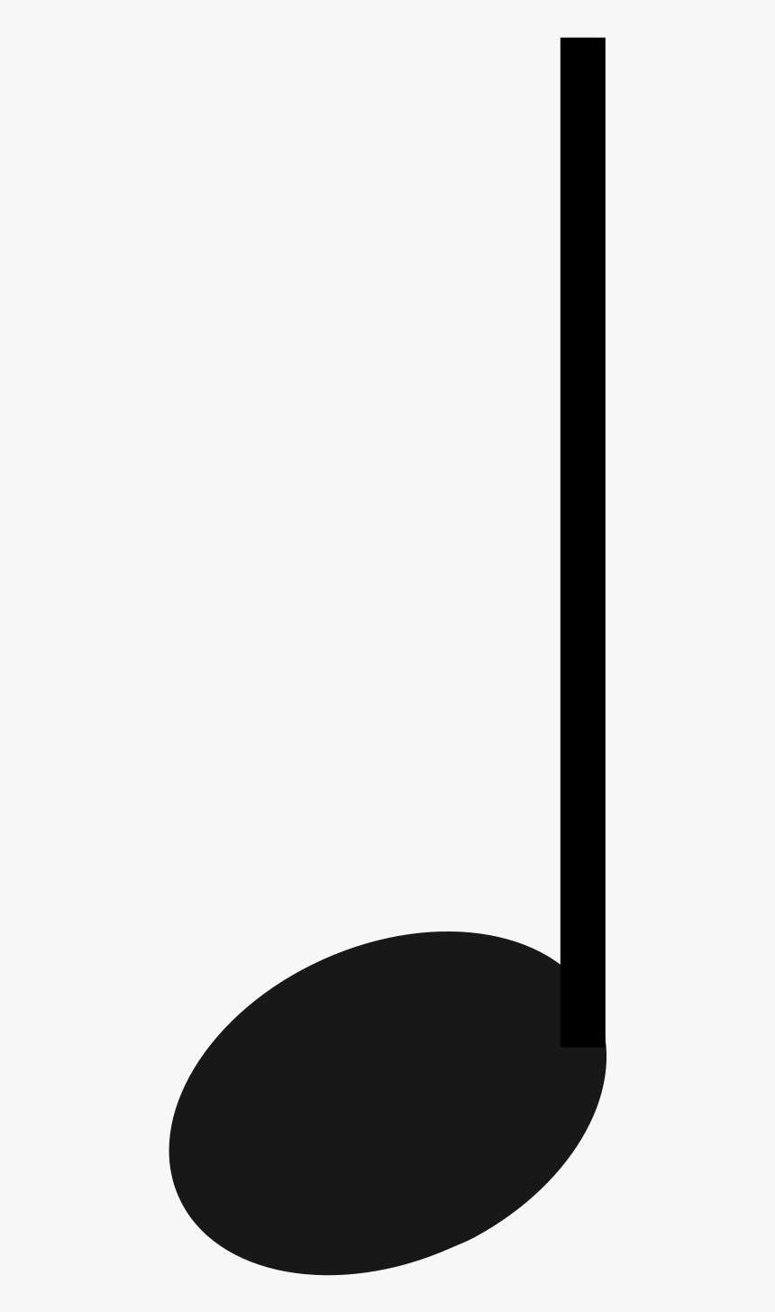) | No (unless it says “yes, but they are dotted”)
Whole note () | No
Crescendo indicator  (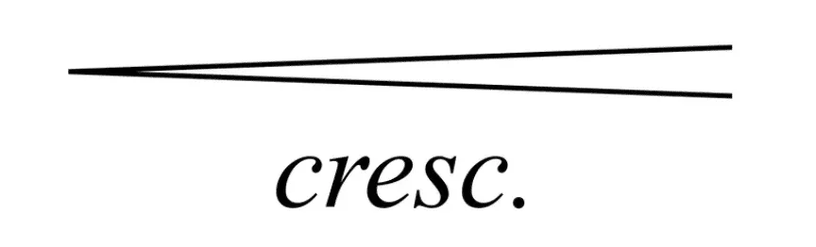,) | No
C major chord | No
Quarter rest (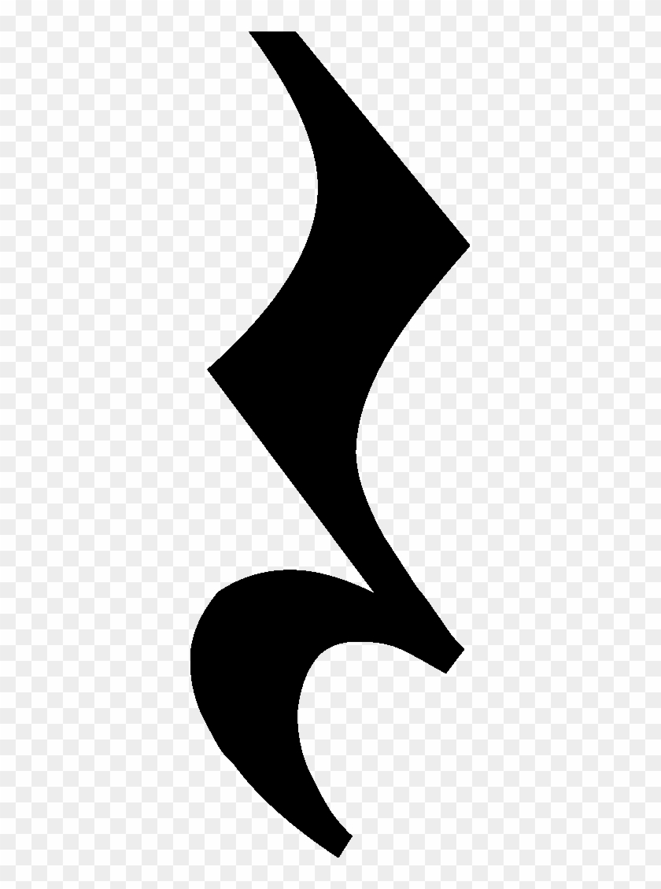) | No
Question 8a (0/1)
Is there information about the speed at which the piece should be played? (e.g., tempo markings like Allegro, Andante, or a BPM number)
1 | “Yes”, at the top of the first measure, above the staff, the word "Allegro" is clearly indicated
0 | “No”, or does not recognize the Allegro.

Question 8b (0/1)
Are there any articulation marks indicating how the piece, or a segment, should be played? (such as ties, legato slurs, dots for staccato, or other articulation marks)
1 | “No”
0 | “Yes”
Question 8c (0/1)
What clefs, if any, are present in this image of the staff?
1 | “Yes”, “treble clef”, “G-Clef”
0 | “No”, or any other answer
Question 9 (0-1)
Based on the musical notation present in the image, how difficult do you think it is to play the excerpt? Rate from 1 to 5, where 1 is easiest and 5 hardest.
1 | - “Medium-easy”, 1-3  - “The notes lie within the typical range of the treble clef”  - “The passage consists mainly of stepwise motion, or small intervallic leaps”  - “The rhythm is quick”
0 | “Very difficult”, 4-5, or hallucinates
Question 10a (melody present) (0/1)
In this excerpt, can the melody “A A B F# F#” be found in the excerpt?
1 | “Yes”
0 | “No”, or any other answer
Question 10b (melody not present) (0/1)
In this excerpt, can the melody “F# D E C#” be found in the excerpt?
1 | “No”
0 | “Yes”, or any other answer

